**Who Should Mourn for Long Island College Hospital?**

*The elderly, residents of a nearby low-income neighborhood and deli owners are bearing the greatest cost of losing a hospital in brownstone Brooklyn. But experts say the impact goes much further.*

Stas Reznik sat in front of his apartment building in Cobble Hill, Brooklyn, sneering at the large poster on the closed hospital across the street that read “The Children’s Hospital of Downstate—Long Island College Hospital.”

“You’d think they’d have taken down the poster,” said Reznik, a photographer who has lived across from Long Island College Hospital (LICH) for 14 years. In just the course of a year, he watched the 156-year-old hospital turn from a bustling full-service medical facility to an emergency room in an otherwise empty building, Reznik said. He has lost almost all his neighbors, including the doctors in residence and staff who used to occupy the buildings next door.

Reznik is among hundreds of people affected by the closing of LICH, the latest of a series of New York hospitals to close in recent years. Certain impacts on the community are immediate. Since the hospital ceased its impatient service on May 22, hundreds of former staff have lost their jobs, more than 20 specialists have left the area and small business owners who used to rely on the hospital for customers struggle to keep their doors open. But closing the 506-bed hospital also has a borough-wide and even citywide effect, said Alan Sager, professor at the Boston University School of Public Health.

“People might look at New York and say there are enough beds, but they are not in the right places, they are in Manhattan,” Sager said. “But you have so many people in Brooklyn but there are not as many beds.” Brooklyn only has 13 of the 26 hospitals it had in the1980s and now the borough of 2.5 million people has a bed-to-population ratio below the national average, department of health data show. “If more hospitals close, we will see a large medical desert,” he said.

The loss of scarce medical resources is especially risky for the elderly and the low-income populations, who typically have more urgent healthcare needs, said Mireille Jacobson, the director of the Center for Health Care Management and Policy at University of California-Irvine.

“Having a hospital close by is essential in case of emergencies,” Jacobson said. “We found when the distance to the nearest hospital increased, death from heart attacks went up.”

About 12,000 of residents within a one-mile radius of LICH are older than 60, 2010 census data shows. Besides, LICH was the closest hospital to the neighborhood of Red Hook, where the majority of the population lives in public housing projects.

The Health Resources and Services Administration labeled Red Hook as a “medically underserved area”, a designation given to areas with too few primary care providers, high infant mortality and high poverty.

“It’s a very scary situation,” Khadijah James, a former EMT and long-time Red Hook resident, said while waiting for a bus that could take her to the New York Methodist Hospital in Park Slope to visit her sister. “I don’t know why they closed it (LICH), it was a good hospital and we used to walk there.”

Fernado Llerandi, who moved to Red Hook less than two years ago, echoed James’ question. “I don’t even know where to go for healthcare anymore, I used to live 10 minutes away from four hospitals,” he said.

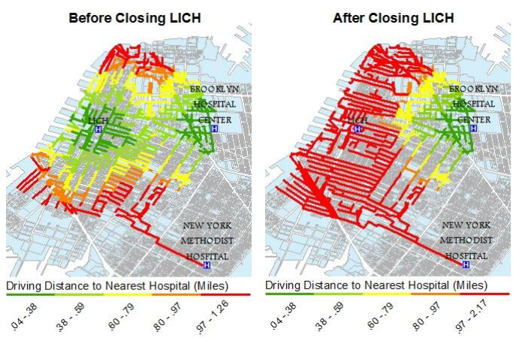

*The closing of LICH increases driving distance to nearest hospitals. (Distance Matters Report, Office of Public Advocate 2013)*

The two closest hospitals—New York Methodist Hospital and Brooklyn Hospital Center in Fort Greene— have also been under stress since LICH stopped accepting ambulances to its emergency room. Many of its former patients have been transferred to their already overcrowded emergency rooms.

Both hospitals have seen increases in the number of patients to their emergency rooms, which already suffer from long waiting times, data from New York State Department of Health show. The agency rates both Methodist and Brooklyn Hospital Center as “poor performers” in emergency department timeliness. Methodist’s ER patients wait on average for 66 minutes to be seen by a professional while those of Brooklyn Hospital Center wait for 114 minutes, compared to the national average of 26 minutes, the data show.

* But given time, both institutions may be able to adjust to the new normal, just like those near St. Vincent’s Hospital did after the Manhattan facility closed in 2010, said Amesh Adalja, senior associate at the University of Pittsburgh Medical Center.
* “What we found was many hospitals used innovative strategies to expand capacity and became more efficient,” Adaljia said. To meet the demand, some hospitals created new operating rooms, some increased staffing or found ways to discharge patients faster. “But you can only do so much, the hospitals are restrained by their physical layout.”
* Lyn Hill, vice president for Communications at New York Methodist Hospital, said the institution has been able to absorb extra patients in its emergency room.

Jeanette Haslett, an emergency department doctor at Brooklyn Hospital Center, said the hospital implemented many changes to accommodate the influx of former LICH patients, such as rearranging the ER room to use formerly vacant space and purchasing reclining treatment chairs that serve as temporary beds.

“We are trying to do the best we can and put chairs where we can,” she said, pointing to the small space next to the door occupied by a treatment chair. The hospital has in fact managed to reduce waiting time through these measures, she said, but winter will pose new challenges. “We will get the true patient flow then,” Haslett said.

**Thrive or Die**

Hospitals are not the only ones bracing for a difficult winter, so are some small businesses close to the former hospital site.

“We are losing a lot of customers that we have known for a long time, workers at the hospital from janitors to nurses to people who work in administration at LICH,” said Saad Almondaser, manager of Champion Deli on Atlantic Street. One fourth of his business vanished after the hospital closed, he said, so his store relies on visitors to the nearby Brooklyn Bridge Park and a few remaining nurses at the emergency room.

But the nurses may leave any time and visitors are unsustainable once the cold weather kicks in. “In the winter nobody is going to go to the park so it’s going to be dead,” he said. “We are trying to figure out how we can manage to get through the winter.”

Across the street from Almondaser’s store, Shoukat Ali was counting the days till he permanently shuts the door on Crown Deli, his home and livelihood for the past 24 years.

The small shop on the corner of Atlantic Avenue and Hicks Street thrived with LICH but now it will die with LICH, he said. Ali kept the shop running during the legal battles over LICH, in hopes that it would remain intact. But after losing more than $35,000, he decided to close the shop this month.

“I don’t know how long it will take for the new buildings to go up, but I can’t wait, I’m losing money,” Ali said.

Although many nearby merchants said they felt the impact of LICH’s closure, none took a toll as as big as Ali’s. Nurses and janitors at LICH were never the main clientele for the diners, bars and boutiques near the hospital, the owners said. Their main business comes from the local residents in Cobble Hill, whose median household income was nearly $40,000 higher than that of New York in 2011, according to city-data.

This is why when Simon Karapetyan took over a deli near LICH this February, he took the advice from a friend working in the neighborhood to make the place “classier” and attract local residents. Karapetyan replaced $1 soft drinks with locally roasted coffee and donut from Dough, redesigned the space to add a bookshelf to the blackboard wall. Within a few months, the Cobble Hill Canteen became a favorite coffee shop among local residents.

To some in the community, LICH was not only an essential healthcare provider but also an entity that held the neighborhood together. “If it’s gone there is something missing, you know? ” said Almondaser.